Project Planning Logic
A sprint is a fixed timebox for a team to complete selected work. An epic groups related stories. Story points are relative estimates, not hours.

Incident project backlog
Epic | Story | Points | Sprint
Requirements | Confirm fields, values, and current rules | 2 | 1
Policy | Configure High Impact Control and actions | 3 | 1
Automation | Create onChange and onSubmit scripts | 3 | 1
Workflow | Add State onCellEdit demonstration | 1 | 2
Validation | Run eight UAT cases | 3 | 2
Handoff | Resolve issues and document rollback | 3 | 2

Estimate and velocity
Initial total estimate: 15 points across two five-day sprints. Planned average is 7.5 points per sprint. This is an assumption, not measured velocity.
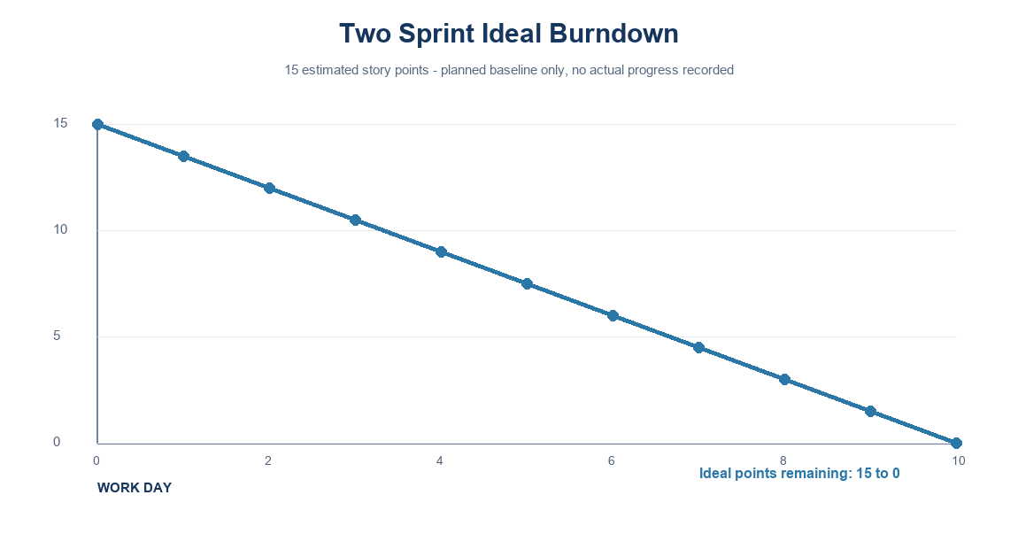
Use actual completed-point data after work begins. Do not report the ideal line as project progress.

Definition of done
Requirements reviewed, configuration checked in a non-production instance, UAT outcomes recorded, severe defects resolved or accepted, and rollback steps reviewed.

